To pursue venerable career in a professional organization  
 enable achieving company’s objectives of development,  
 customer pleasure and service.

**OBJECTIVES**

* Tolerant and flexible, adjusts to different situations
* Responsible, resourceful, honest, dedicated, and hardworking
* Computer and Internet Skills
* Multitasking
* Knowledgeable in MS Office applications (Word, Excel, Powerpoint)
* Fast typing skills and efficient filing techniques

**QUALIFICATIONS**

2015 **Tech Tutor 7**  
 *SM Megatrade Hall 2  
 Sept 30, 2015*  
  
2015 **ITWOW!***San Sebastian College – Recoletos de Cavite  
 Oct 13, 2015*  
  
2016 **Tech Tutor 8**

*SM Megatrade Hall 1 & 2*

*Sep. 28, 2016*

**SEMINARS ATTENDED**

Birthdate – **Aug 10, 1998**Place of Birth **– Tanza, Cavite**Height – **5’6”**Weight – **52 kg**Citizenship – **Filipino**Civil Status – **Single**Religion **– Roman Catholic**

**PERSONAL INFORMATION**

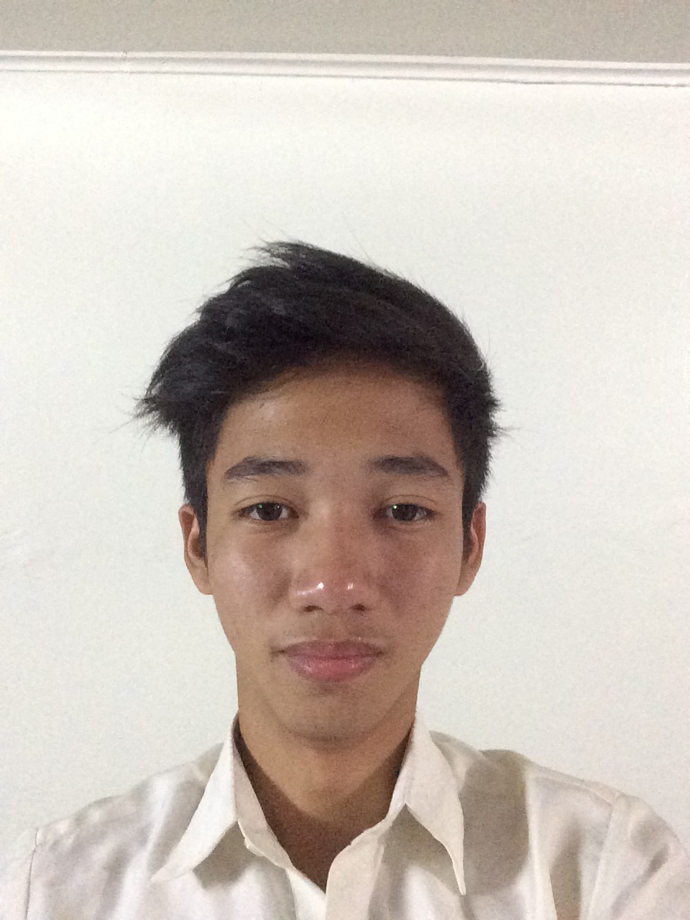

**JAMINAL, IVAN ASHLEY F.**

🖂 : **21 Gahak, Kawit, Cavite**

**🕿** : **09776783594**

📭 : **Jaminal_ivan@yahoo.com.ph**

**Mr. Antonio C. Co, MBA**

*Head, Computer Studies Department*

*San Sebastian College – Recoletos de Cavite*

**Mrs. Agnes V. Bernal***Faculty, Computer Studies Department  
San Sebastian College – Recoletos de Cavite*

**REFERENCES**

**Member**, **Alliance of Hospitality Associates (AHA**)   
*San Sebastian College – Recoletos de Cavite 2014*

**Member**, **Junior Philippines Computer Society (JPCS)**   
*San Sebastian College – Recoletos de Cavite 2015-PRESENT*

**AFFILIATIONS**

**Tertiary Education** San Sebastian College - Recoletos de Cavite  
 Cavite City, Cavite  
 2016-Present  
 **Secondary Education** Patnubay Academy  
 San Juan, Noveleta, Cavite  
 2010-2014

**EDUCATIONAL ATTAINTMENT**